Article on Insurance Fraud

**Problem Definition:**

In the auto insurance industry, the pervasive issue of insurance fraud poses significant challenges. Identifying fraudulent claims is notoriously difficult, leading to substantial financial losses for insurers and higher premiums for honest policyholders. Leveraging machine learning presents a unique opportunity to address this problem effectively. By utilizing predictive modelling techniques on comprehensive datasets encompassing insurance policies, customer information, and accident details, we aim to develop models capable of accurately distinguishing between fraudulent and legitimate insurance claims. This article explores the potential of machine learning in combating insurance fraud within the auto insurance sector, offering insights into the development and deployment of predictive models to safeguard against fraudulent activities.

**Data Analysis:**

To gain insights into the provided dataset and understand its underlying characteristics, we conducted an exploratory data analysis (EDA) covering various aspects of the data. The analysis aimed to uncover patterns, relationships, and potential indicators of insurance fraud.

**Data Overview**

The dataset contains a total of 40 independent variables, including features such as months_as_customer, age, policy details, incident characteristics, and vehicle information.

The target variable, fraud_reported, indicates whether a claim is fraudulent or not.

**Feature Distribution**

We examined the distribution of key features to understand their ranges and variability across the dataset.

Features such as age, policy_annual_premium, total_claim_amount, and others were analyzed to identify any notable trends or outliers.

**Correlation Analysis**

We investigated correlations between different variables to identify potential relationships and dependencies.

Correlation matrices were generated to visualize the strength and direction of correlations between numerical features.

**Target Variable Analysis**

We explored the distribution of the target variable, fraud_reported, to understand the class balance and prevalence of fraudulent claims in the dataset.

Class distributions were examined to assess the imbalance between fraudulent and non-fraudulent claims.

**Temporal Analysis**

Temporal features such as incident_date, incident_hour_of_the_day, and auto_year were analyzed to uncover any temporal patterns or trends in insurance claims.

Seasonality and time-of-day effects on claim frequency and fraud occurrence were examined.

**Categorical Variables**

Categorical variables such as policy_state, insured_sex, incident_type, and auto_make were analyzed to understand their distributions and potential impact on fraud detection.

Frequency counts and proportions of different categories within each variable were calculated.

**Missing Values and Data Quality**

We assessed the presence of missing values and inconsistencies within the dataset.

Techniques such as imputation or deletion were applied to handle missing data and ensure data quality for subsequent analysis.

**Visualization**

Various visualization techniques, including histograms, box plots, scatter plots, and bar charts, were utilized to visually explore the data and uncover insights.

Visual representations were used to convey patterns, trends, and relationships in the data effectively.

**Insights**

Based on the data analysis, certain features and variables emerged as potential indicators of insurance fraud.

Insights gained from the analysis will inform the development of predictive models aimed at detecting fraudulent claims in the auto insurance industry.

**Next Steps**

The insights obtained from the data analysis will guide the subsequent steps in model development, including feature selection, model selection, and evaluation.

Further analysis and feature engineering may be conducted to refine the predictive models and improve their performance in detecting insurance fraud.

This data analysis lays the foundation for developing robust predictive models to address the challenge of insurance fraud in the auto insurance industry. By leveraging insights from the analysis, we aim to build effective tools for fraud detection and prevention, ultimately benefiting both insurers and policyholders.

**EDA Remarks:**

During the exploratory data analysis (EDA) of the provided dataset, several noteworthy observations and insights were uncovered:

**Feature Distribution**:

The distribution of features such as age, policy_annual_premium, and total_claim_amount exhibited variability across the dataset.

Some features showed skewed distributions or outliers, indicating potential areas for further investigation or data preprocessing.

**Correlation Analysis**:

Correlation analysis revealed potential relationships between numerical features, providing insights into variables that may influence each other.

Strong correlations between certain features may indicate multicollinearity, which could impact the performance of predictive models if not addressed appropriately.

**Target Variable Analysis**:

The distribution of the target variable, fraud_reported, indicated class imbalance, with a relatively small proportion of fraudulent claims compared to non-fraudulent claims.

Class distributions need to be taken into account during model training to prevent bias towards the majority class and ensure accurate predictions for both classes.

**Temporal Analysis**:

Temporal analysis of features such as incident_date and incident_hour_of_the_day revealed potential patterns or trends in insurance claims over time.

Understanding temporal effects on claim frequency and fraud occurrence is crucial for developing effective fraud detection strategies.

**Categorical Variables**:

Analysis of categorical variables provided insights into the distribution of different categories and their potential impact on fraud detection.

Certain categories within variables such as policy_state, insured_sex, and incident_type may be associated with higher or lower incidences of insurance fraud.

**Missing Values and Data Quality**:

Assessment of missing values and data inconsistencies highlighted the need for data preprocessing steps to ensure data quality and integrity.

Strategies for handling missing data, such as imputation or deletion, may impact the analysis and subsequent model development.

**Visualization**:

Visualizations such as histograms, box plots, and scatter plots were effective in revealing patterns, trends, and relationships in the data.

Visual representations aided in conveying complex information and facilitating understanding of the dataset's characteristics.

**Insights**:

Insights gained from the EDA phase will inform subsequent steps in model development, including feature selection, model selection, and evaluation.

Identified patterns or trends may serve as valuable inputs for building predictive models aimed at detecting insurance fraud.

The EDA process provided valuable insights into the dataset's characteristics and laid the groundwork for developing effective predictive models to address the challenge of insurance fraud in the auto insurance industry. Further analysis and refinement will be conducted to enhance model performance and contribute to fraud detection and prevention efforts.

**Building Machine Learning Models:**

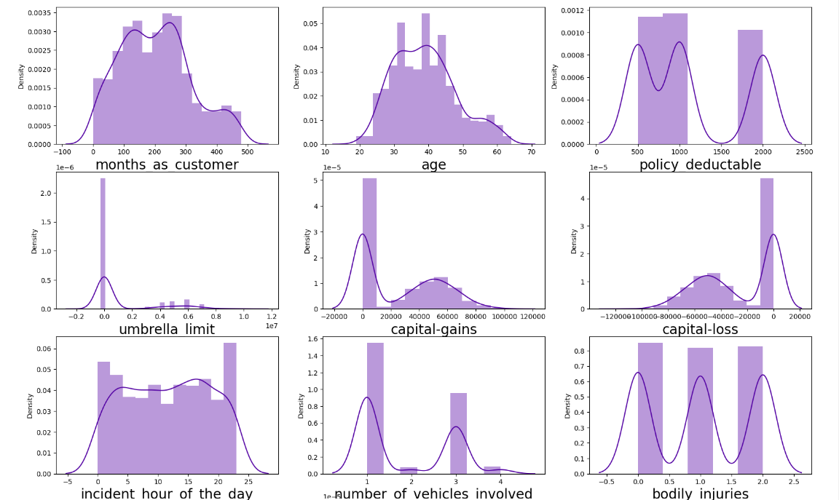

**Concluding Remarks:**

In conclusion, the application of machine learning models for insurance fraud detection in the auto insurance industry represents a significant advancement in safeguarding against fraudulent activities. By harnessing the power of data analytics and predictive modelling, insurers can proactively identify and mitigate the financial risks associated with fraudulent insurance claims.

Through thorough data preprocessing, model selection, training, and evaluation, insurers can develop robust machine learning models capable of accurately detecting fraudulent claims while minimizing false positives. These models not only enhance the efficiency of fraud detection processes but also contribute to reducing financial losses and maintaining trust within the insurance ecosystem.

Furthermore, the interpretability of machine learning models enables insurers to gain valuable insights into the underlying factors driving fraudulent behaviour, empowering them to make informed decisions and implement targeted interventions to combat fraud effectively.

However, it is essential to recognize the ethical considerations associated with deploying machine learning models for insurance fraud detection. Insurers must prioritize fairness, transparency, and privacy protection throughout the model development and deployment process, ensuring that the models do not inadvertently perpetuate bias or discrimination.

In essence, the integration of machine learning technology into insurance fraud detection represents a proactive and forward-thinking approach to risk management in the auto insurance industry. By leveraging data-driven insights and predictive analytics, insurers can stay ahead of emerging fraud trends, protect their assets, and uphold the integrity of the insurance marketplace for the benefit of all stakeholders involved.